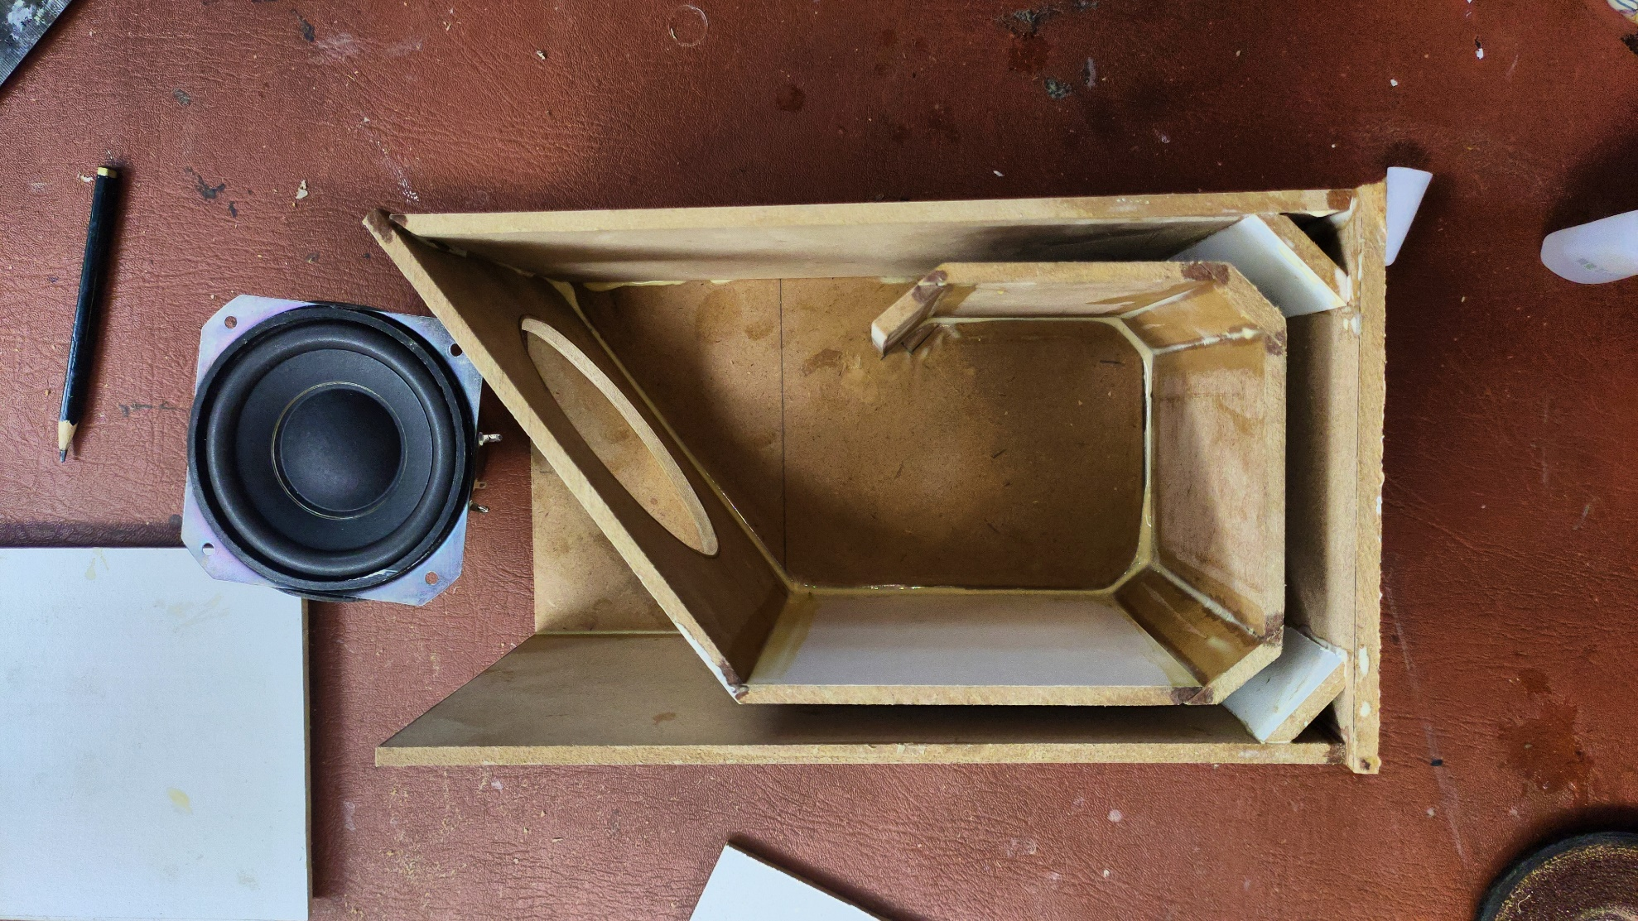

13 CM

1.0 CM

15 CM

7 CM

1.2 CM

10 CM

10 CM

10 CM

26 CM